ACTIVITY BASED LEARNING ASSIGNMENT – PYTHON
10 – Case Studies
Case Study 1: Attendance Recovery System
1. Problem Statement
Develop a Python program to calculate a student's attendance percentage and determine whether the student is eligible based on the minimum attendance requirement of 75%.
2. Objectives
- To calculate the attendance percentage.
- To check whether the student meets the minimum attendance requirement.
- To display the student's eligibility status.
3. Assumptions
- The total number of classes must be greater than zero.
- The attended classes cannot be negative.
- The attended classes cannot exceed the total classes.
- The minimum required attendance is 75%.
4. Algorithm
- Start the program.
- Input the total number of classes.
- Input the number of classes attended.
- Check whether the input values are valid.
- If the percentage is greater than or equal to 75%, display "Eligible".
- Otherwise, display "Not eligible".
- If the inputs are invalid, display "Invalid input".
- Stop the program.
5. Pseudocode
BEGIN
INPUT total_classes
INPUT attended_classes
IF total_classes > 0 AND
attended_classes >= 0 AND
attended_classes <= total_classes THEN
CALCULATE percentage =
(attended_classes / total_classes) * 100
DISPLAY percentage
IF percentage >= 75 THEN
DISPLAY "Eligible"
ELSE
DISPLAY "Not eligible"
ENDIF
ELSE
DISPLAY "Invalid input"
ENDIF
END

6.Flowchart
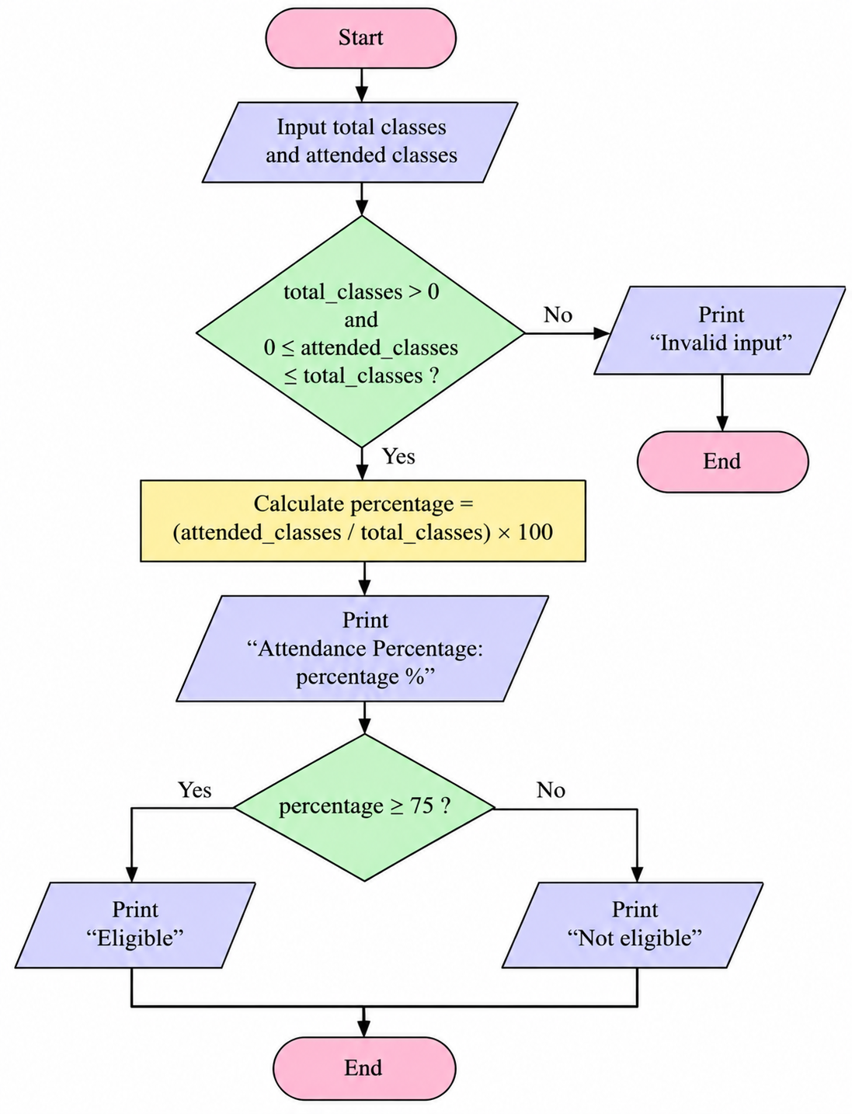
7. Test Cases
Test Case | Total Classes | Attended Classes | Expected Result
1 | 100 | 80 | Eligible
2 | 100 | 60 | Not eligible
3 | 0 | 0 | Invalid input
4 | 50 | 55 | Invalid input
Conclusion
The Python program successfully calculates the student's attendance percentage and checks eligibility according to the 75% attendance requirement. It also handles invalid input values.

Output:
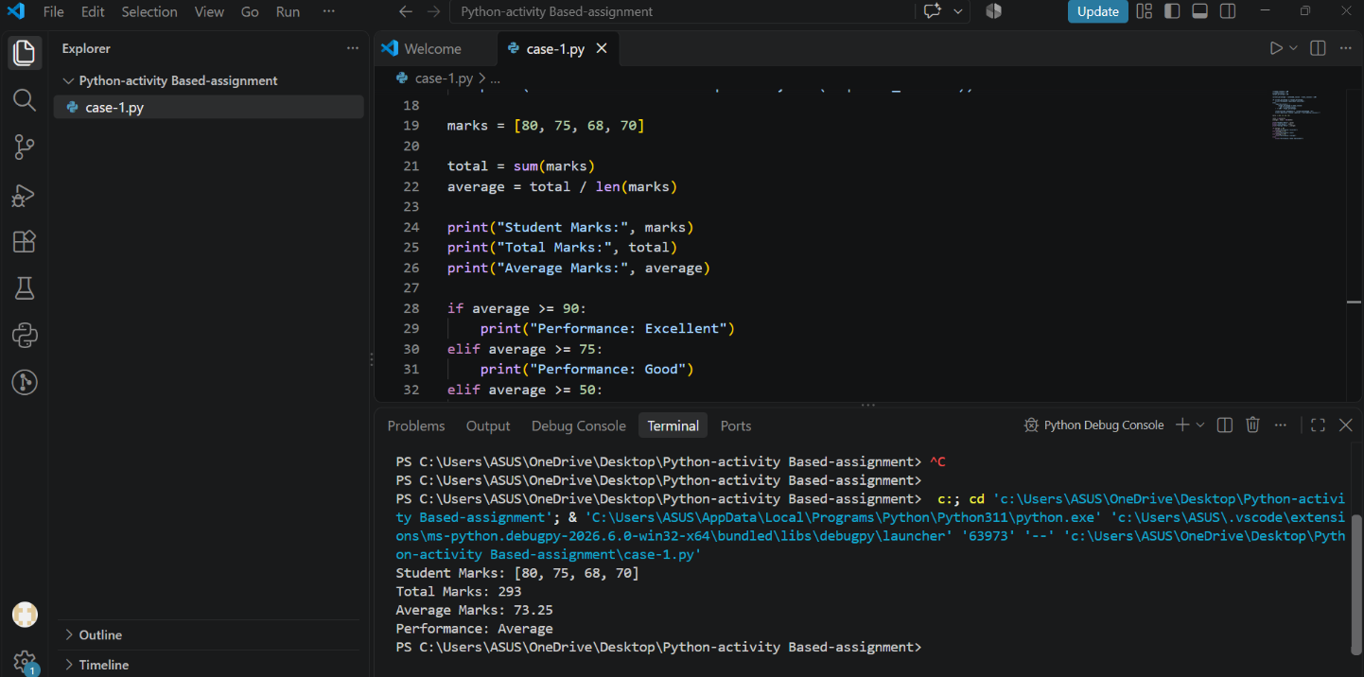

Case Study 2: Student Performance Trend Analysis
1. Problem Statement
Develop a Python program to calculate a student's average marks in three subjects and determine the student's performance based on the average marks.
2. Objectives
- To accept marks in three subjects.
- To calculate the total and average marks.
- To classify the student's performance based on the average.
- To display the total, average, and performance result.
3. Assumptions
- Marks are entered out of 100 for each subject.
- Marks must be between 0 and 100.
- All three subjects have equal weight.
4. Algorithm
- Start the program.
- Input marks in three subjects.
- Check whether all marks are between 0 and 100.
- Calculate the total marks.
- Calculate the average marks by dividing the total by 3.
- If the average is at least 90, display "Excellent".
- Otherwise, if the average is at least 75, display "Very Good".
- Otherwise, if the average is at least 60, display "Good".
- Otherwise, display "Needs Improvement".
- If the marks are invalid, display "Invalid marks".
- Stop the program.

5. Pseudocode
BEGIN
INPUT marks1
INPUT marks2
INPUT marks3
IF marks1 >= 0 AND marks1 <= 100 AND
marks2 >= 0 AND marks2 <= 100 AND
marks3 >= 0 AND marks3 <= 100 THEN
CALCULATE total = marks1 + marks2 + marks3
CALCULATE average = total / 3
DISPLAY total
DISPLAY average
IF average >= 90 THEN
DISPLAY "Excellent"
ELSE IF average >= 75 THEN
DISPLAY "Very Good"
ELSE IF average >= 60 THEN
DISPLAY "Good"
ELSE
DISPLAY "Needs Improvement"
ENDIF
ELSE
DISPLAY "Invalid marks"
ENDIF
END

- Flowchart

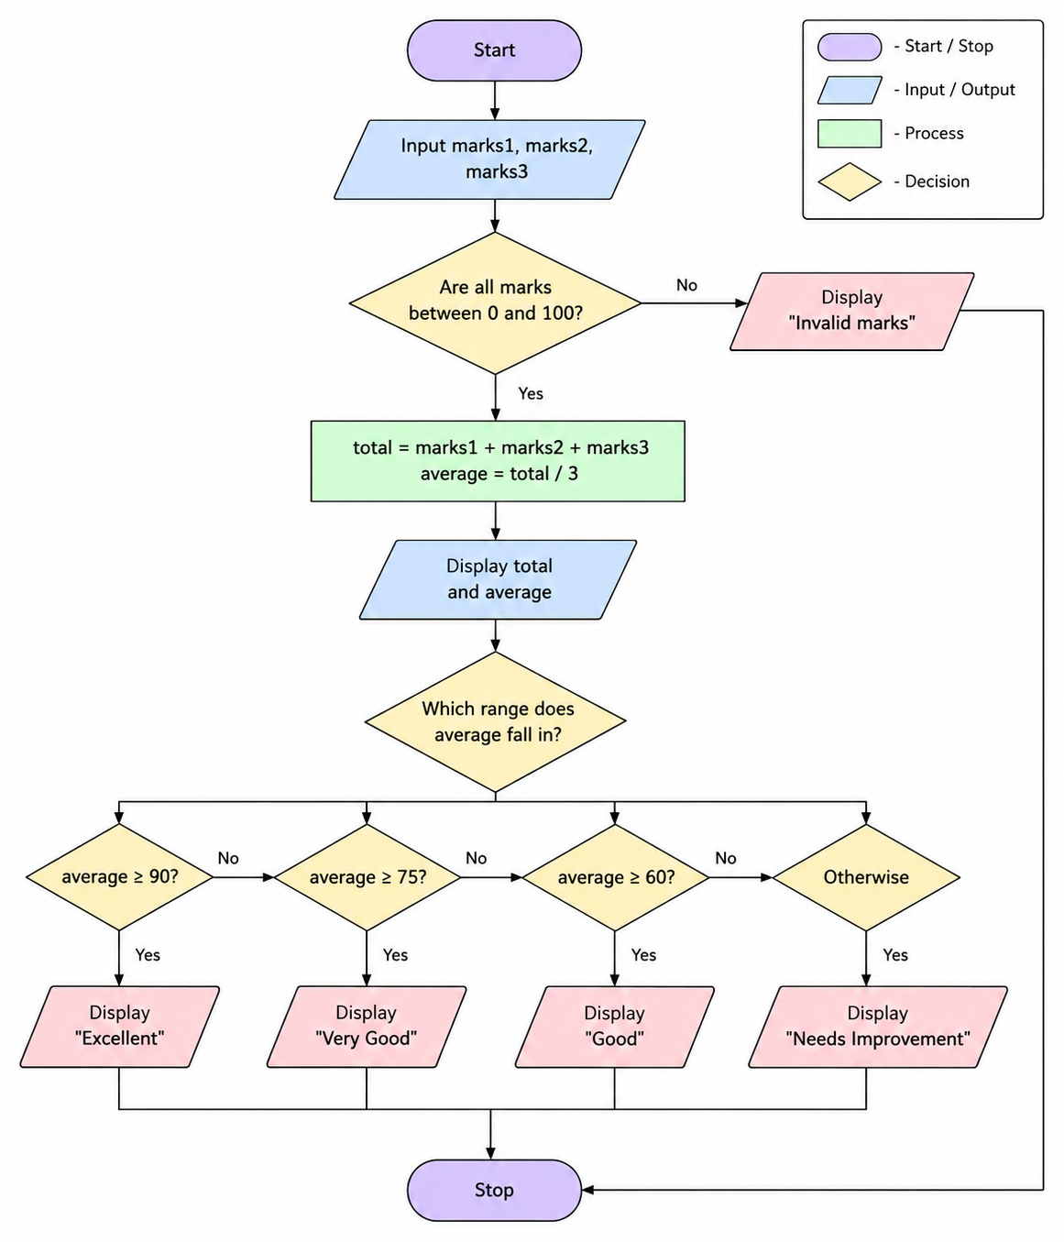

Output:
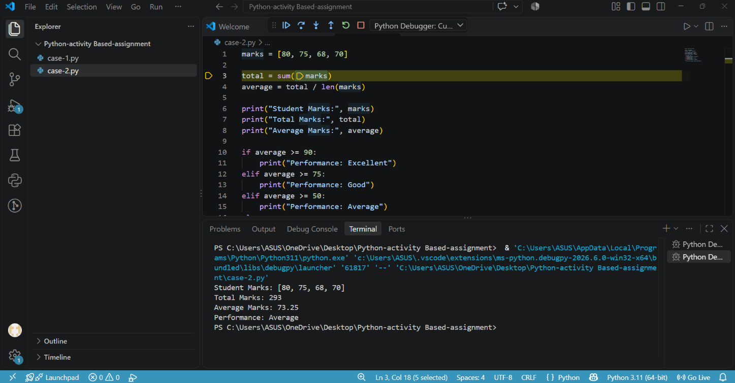

Case Study 3: String-Based Examination Answer Evaluation
1. Problem Statement
Develop a Python program to compare a student's answers with an answer key and calculate the number of correct, incorrect, and unanswered questions.
2. Objectives
- To compare student answers with the answer key.
- To count correct, incorrect, and unanswered questions.
- To calculate the student's total score.
- To display the evaluation results.
3. Assumptions
- The answer key contains the correct answers.
- The student's answers must have the same length as the answer key.
- A hyphen (-) represents an unanswered question.
- Each correct answer carries 1 mark.
- No negative marks are given for incorrect answers.
4. Algorithm
- Start the program.
- Input the answer key.
- Input the student's answers.
- Check whether both strings have the same length.
- Initialize correct, incorrect, and unanswered counts to zero.
- Compare each student's answer with the corresponding answer key.
- If the answer is -, increase the unanswered count.
- If the answer matches the key, increase the correct count.
- Otherwise, increase the incorrect count.
- Calculate the score using the number of correct answers.
- Display all results.
- Stop the program.
5. Pseudocode
BEGIN
INPUT answer_key
INPUT student_answers
IF LENGTH(answer_key) = LENGTH(student_answers) THEN
PROCESS correct = 0
PROCESS incorrect = 0
PROCESS unanswered = 0
FOR each position in the answers
IF student_answer = "-" THEN
PROCESS unanswered = unanswered + 1
ELSE IF student_answer = answer_key THEN
PROCESS correct = correct + 1
ELSE
PROCESS incorrect = incorrect + 1
ENDIF
ENDFOR
PROCESS score = correct * 1
OUTPUT correct
OUTPUT incorrect
OUTPUT unanswered
OUTPUT score
ELSE
OUTPUT "Invalid input"
ENDIF
END

- Flowchart
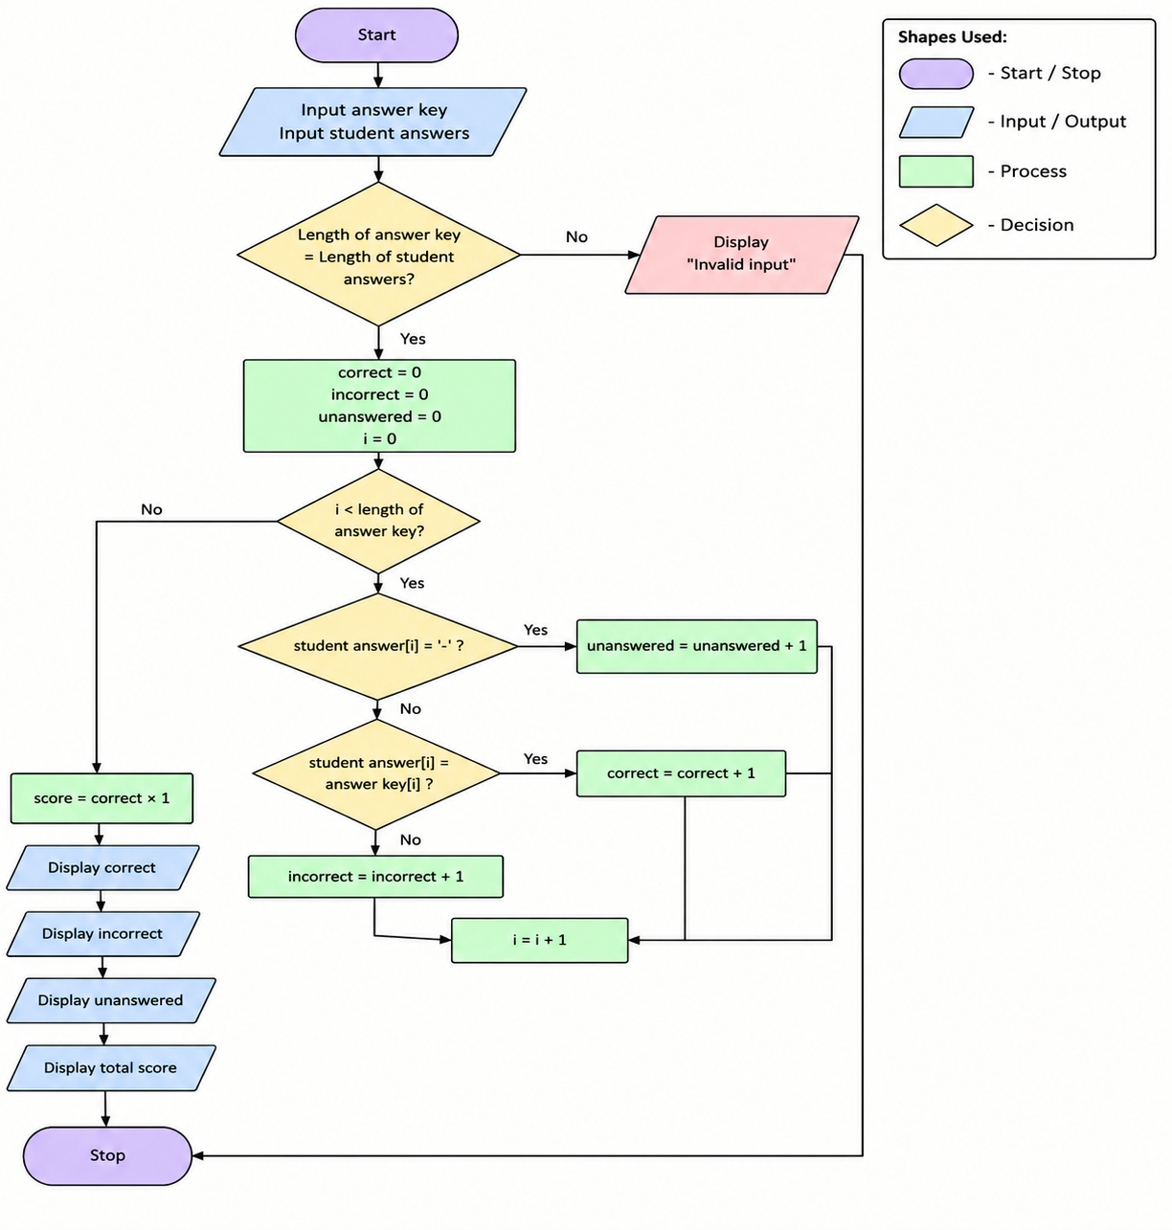

7. Test Cases
Test Case | Answer Key | Student Answers | Expected Result
1 | ABCD | ABCD | 4 correct
2 | ABCD | ABAD | 3 correct, 1 incorrect
3 | ABCD | AB-D | 2 correct, 1 incorrect, 1 unanswered
4 | ABCD | ABC | Invalid input
Conclusion
The Python program successfully evaluates examination answers by comparing strings. It counts correct, incorrect, and unanswered questions and calculates the total score.
Output:
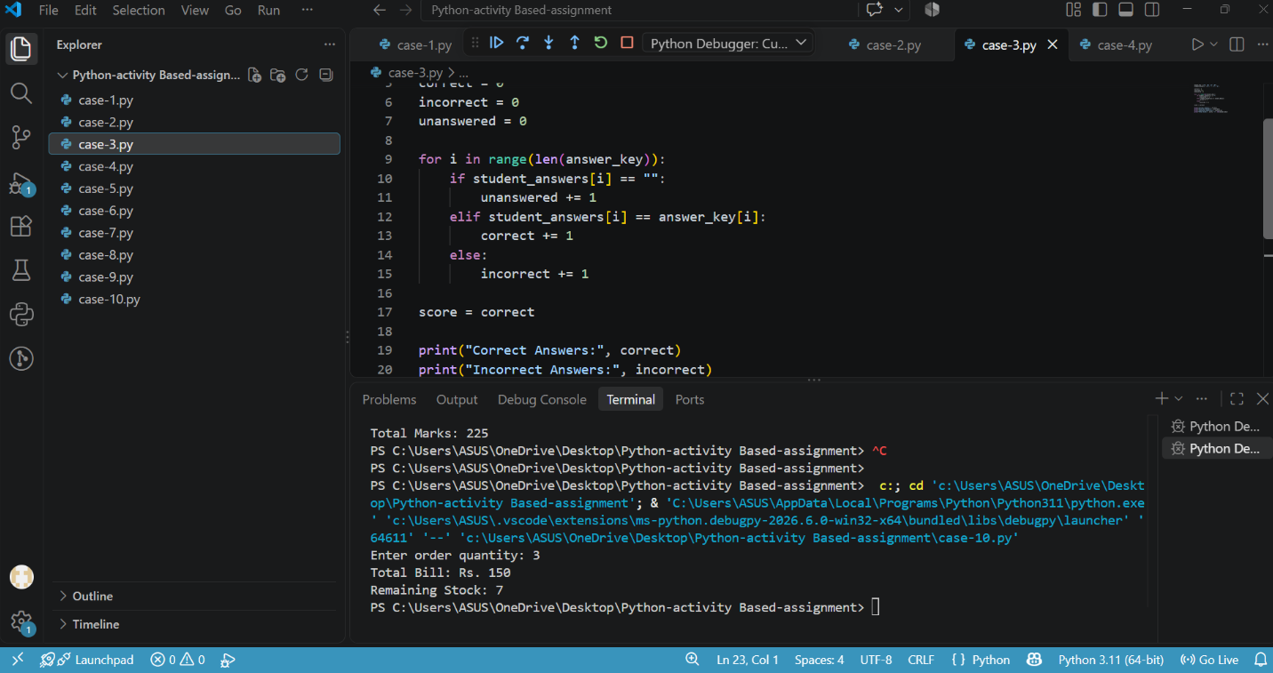

Case Study 4: Retail Billing with Multiple Discount Rules
1. Problem Statement
Develop a Python program to calculate the final bill amount for a customer by applying discounts based on the purchase amount.
2. Objectives
- To accept the purchase amount from the customer.
- To calculate the discount based on the purchase amount.
- To calculate the final bill amount.
- To display the purchase amount, discount, and final bill.
3. Assumptions
- The purchase amount must be greater than zero.
- If the purchase amount is ₹5,000 or more, the discount is 20%.
- If the purchase amount is ₹2,000 or more but less than ₹5,000, the discount is 10%.
- If the purchase amount is less than ₹2,000, no discount is given.
- No additional taxes are included.
4. Algorithm
- Start the program.
- Input the purchase amount.
- Check whether the purchase amount is valid.
- If the amount is ₹5,000 or more, calculate a 20% discount.
- Otherwise, if the amount is ₹2,000 or more, calculate a 10% discount.
- Otherwise, set the discount to zero.
- Calculate the final bill by subtracting the discount from the purchase amount.
- Display the purchase amount, discount, and final bill.
- If the input is invalid, display "Invalid amount".
- Stop the program.

5. Pseudocode
BEGIN
INPUT purchase_amount
IF purchase_amount > 0 THEN
IF purchase_amount >= 5000 THEN
CALCULATE discount = purchase_amount * 0.20
ELSE IF purchase_amount >= 2000 THEN
CALCULATE discount = purchase_amount * 0.10
ELSE
PROCESS discount = 0
ENDIF
CALCULATE final_bill = purchase_amount - discount
DISPLAY purchase_amount
DISPLAY discount
DISPLAY final_bill
ELSE
DISPLAY "Invalid amount"
ENDIF
END

6.Flowchart
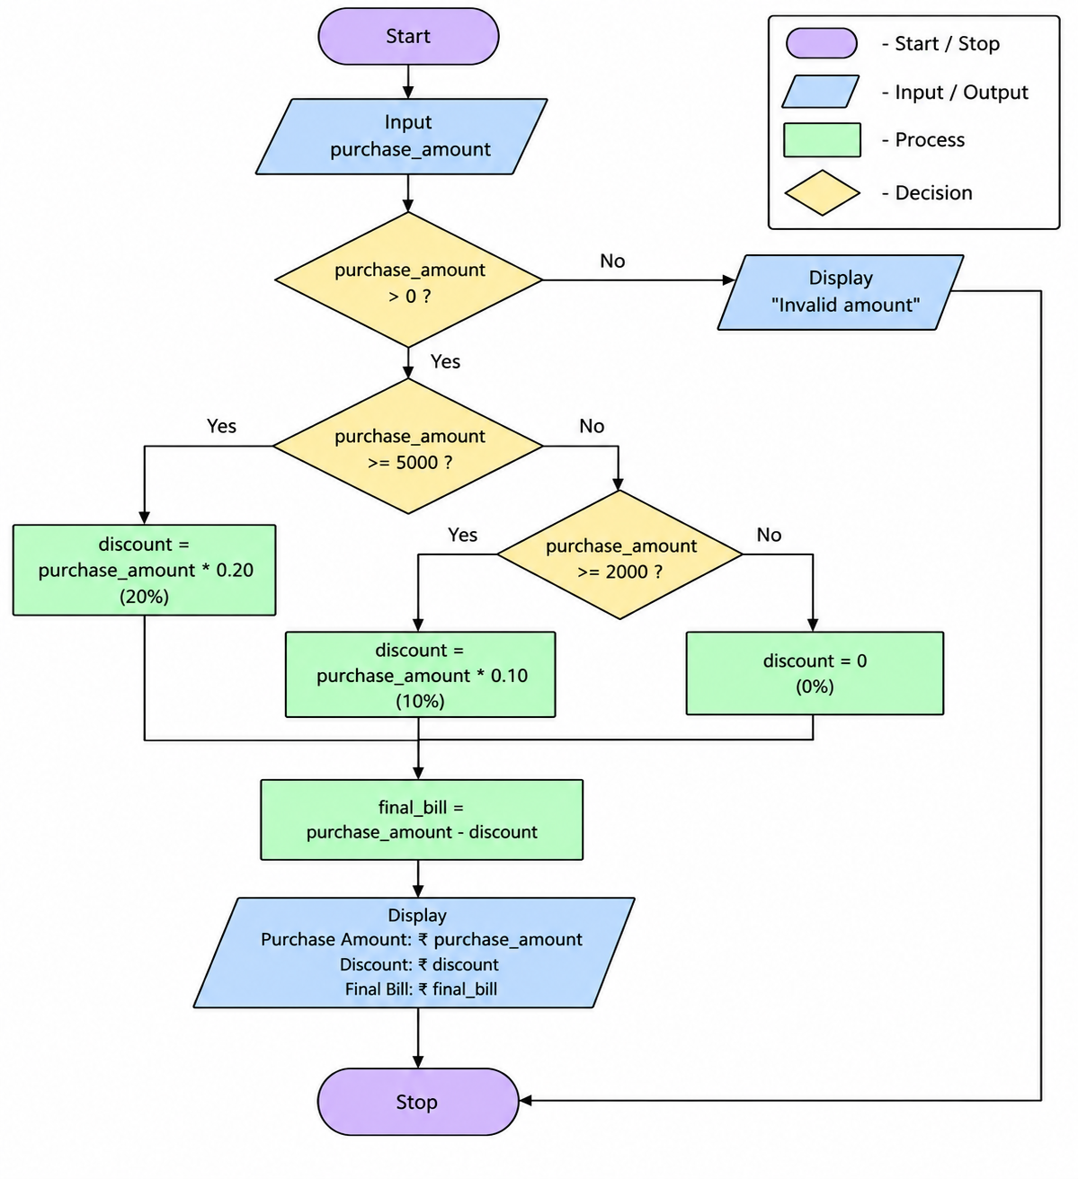
7. Test Cases
Test Case | Purchase Amount | Expected Discount | Expected Final Bill
1 | ₹6,000 | ₹1,200 | ₹4,800
2 | ₹3,000 | ₹300 | ₹2,700
3 | ₹1,000 | ₹0 | ₹1,000
4 | ₹0 | Invalid | Invalid amount
Conclusion
The Python program successfully calculates the discount and final bill amount based on the customer's purchase amount. It applies the appropriate discount rule and handles invalid amounts.
Output:
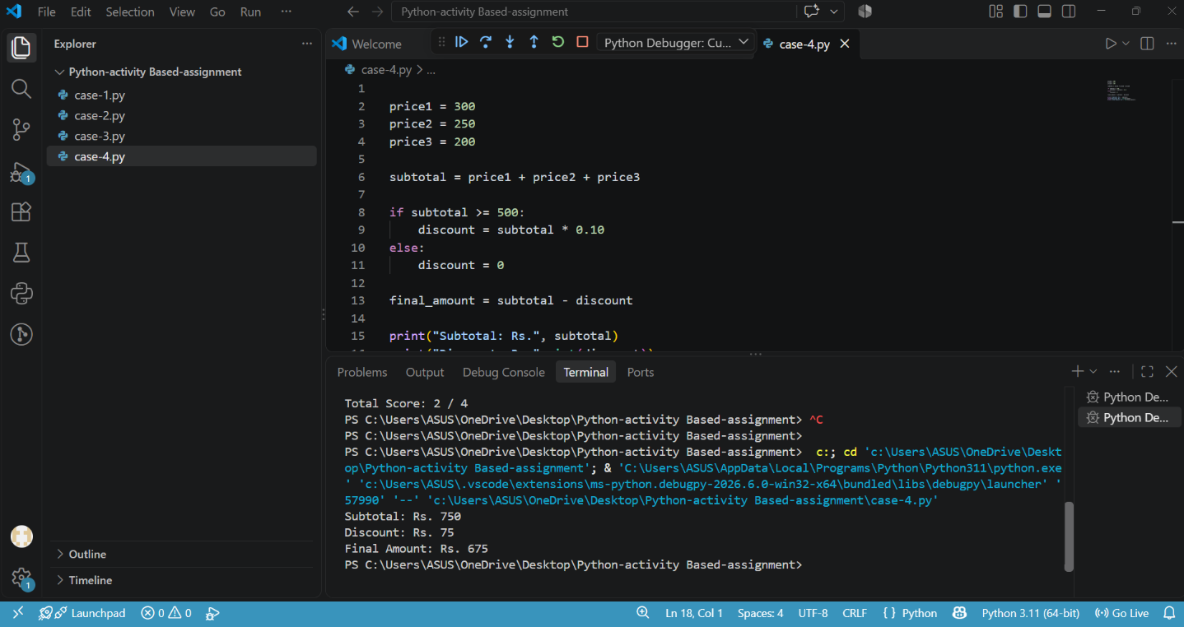

Case Study 5: ATM Transaction Sequence Simulation
1. Problem Statement
Develop a Python program to simulate ATM transactions by allowing a user to check their balance, deposit money, and withdraw money while maintaining the correct account balance.
2. Objectives
- To simulate basic ATM operations.
- To allow deposits and withdrawals.
- To check the available balance before withdrawal.
- To display the updated account balance.
3. Assumptions
- The initial account balance is ₹5,000.
- The user selects an operation from the menu.
- Deposit and withdrawal amounts must be greater than zero.
- A withdrawal cannot exceed the available balance.
- The program supports checking balance, depositing money, and withdrawing money.
4. Algorithm
- Start the program.
- Set the initial balance to ₹5,000.
- Display the ATM menu.
- Ask the user to select an operation.
- If the user selects Check Balance, display the current balance.
- If the user selects Deposit, input the amount and update the balance.
- If the user selects Withdraw, input the amount and check whether sufficient balance is available.
- If the amount is valid and sufficient balance exists, subtract it from the balance.
- Display the updated balance.
- If the user selects an invalid option, display "Invalid choice".
- Stop the program.
5. Pseudocode
BEGIN
PROCESS balance = 5000
OUTPUT "1. Check Balance"
OUTPUT "2. Deposit"
OUTPUT "3. Withdraw"
INPUT choice
IF choice = 1 THEN
OUTPUT balance
ELSE IF choice = 2 THEN
INPUT amount
IF amount > 0 THEN
PROCESS balance = balance + amount
OUTPUT balance
ELSE
OUTPUT "Invalid amount"
ENDIF
ELSE IF choice = 3 THEN
INPUT amount
IF amount > 0 AND amount <= balance THEN
PROCESS balance = balance - amount
OUTPUT balance
ELSE
OUTPUT "Insufficient balance or invalid amount"
ENDIF
ELSE
OUTPUT "Invalid choice"
ENDIF
END
6.Flowchart
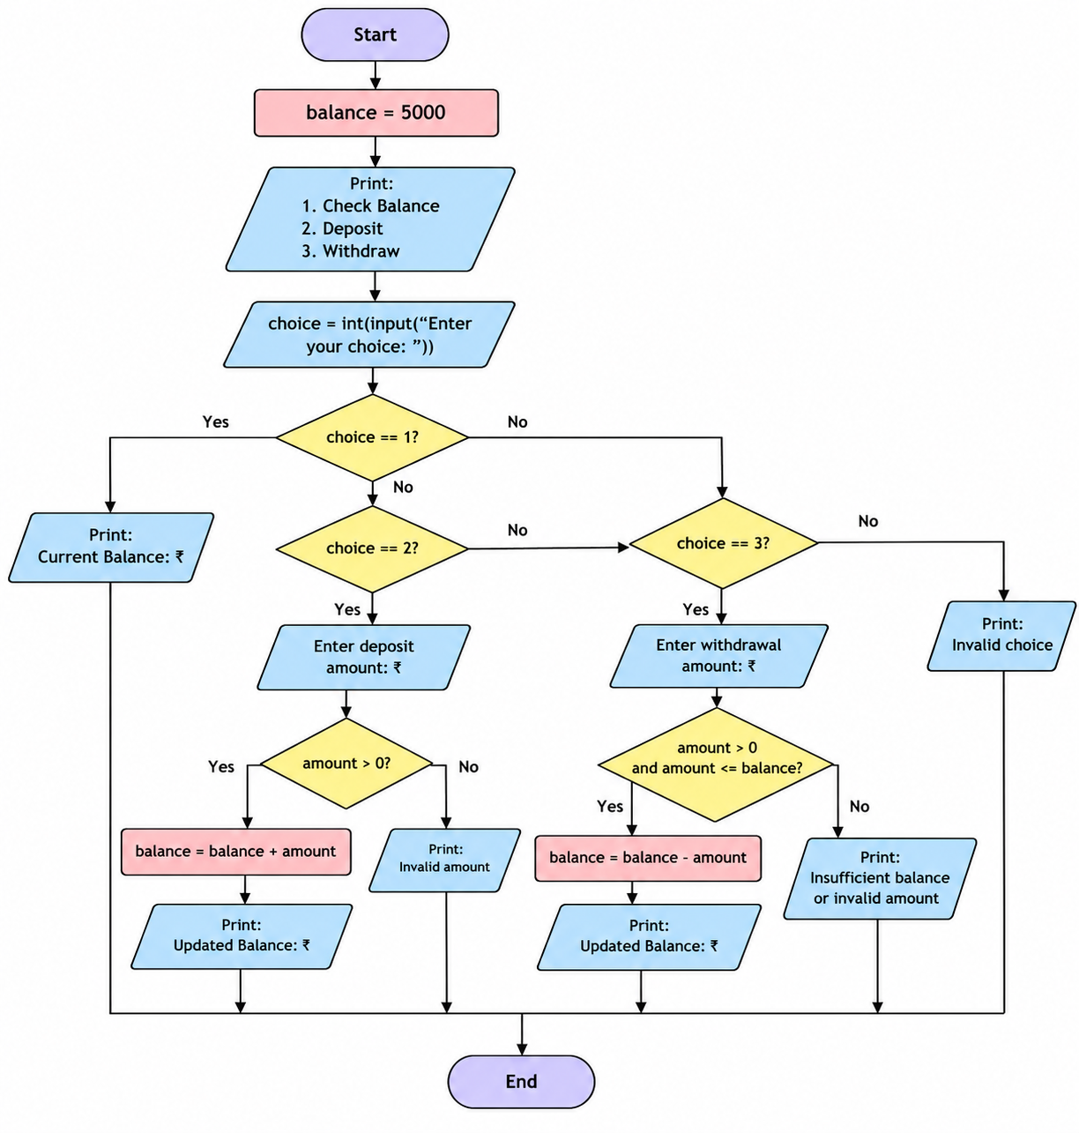
7. Test Cases
Test Case | Choice | Amount | Expected Result
1 | 1 — Check Balance | — | Balance ₹5,000
2 | 2 — Deposit | ₹1,000 | Balance ₹6,000
3 | 3 — Withdraw | ₹2,000 | Balance ₹3,000
4 | 3 — Withdraw | ₹6,000 | Insufficient balance
5 | 2 — Deposit | ₹0 | Invalid amount
6 | 4 — Invalid option | — | Invalid choice
Conclusion
The Python program successfully simulates basic ATM operations, including balance checking, depositing, and withdrawing money. It validates transaction amounts and prevents withdrawals exceeding the available balance.
Output:
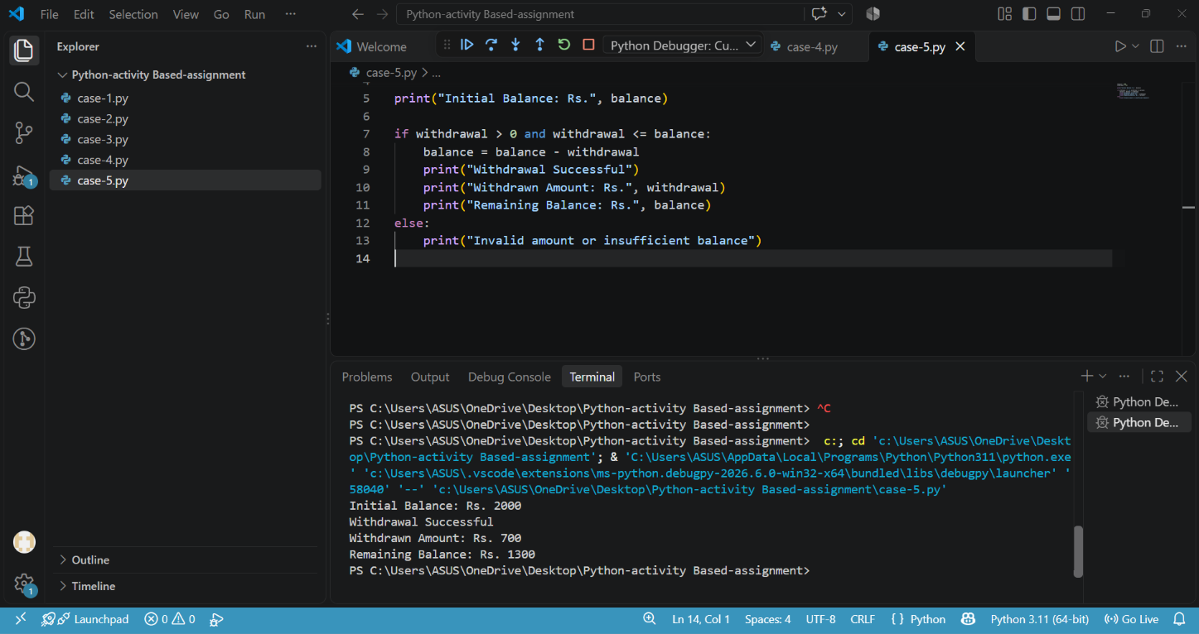

Case Study 6: Student Timetable Conflict Detection
1. Problem Statement
Develop a Python program to check whether two classes are scheduled at the same time and identify timetable conflicts.
2. Objectives
- To accept the timings of two classes.
- To compare the class timings.
- To identify whether a timetable conflict exists.
- To display the result.
3. Assumptions
- Class timings are entered using 24-hour format (for example, 10 for 10 AM).
- The start time must be earlier than the end time.
- Both classes occur on the same day.
- Two classes conflict if their time periods overlap.
4. Algorithm
- Start the program.
- Input the start and end times of Class 1.
- Input the start and end times of Class 2.
- Check whether the timings are valid.
- Compare the two class time periods.
- If the periods overlap, display "Timetable conflict detected".
- Otherwise, display "No timetable conflict".
- If the timings are invalid, display "Invalid time".
- Stop the program.
5. Pseudocode
BEGIN
INPUT start1, end1
INPUT start2, end2

IF start1 < end1 AND start2 < end2 THEN
IF start1 < end2 AND start2 < end1 THEN
DISPLAY "Timetable conflict detected"
ELSE
DISPLAY "No timetable conflict"
ENDIF
ELSE
DISPLAY "Invalid time"
ENDIF
END
6.Flowchart

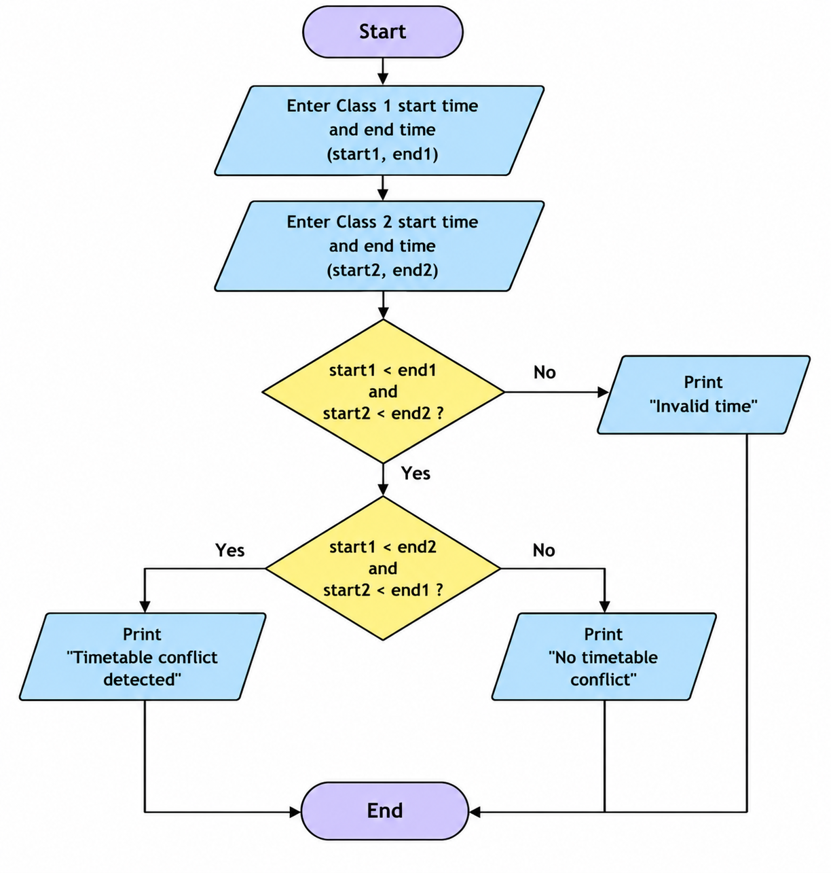
7. Test Cases
Test Case | Class 1 | Class 2 | Expected Result
1 | 9–11 | 10–12 | Conflict detected
2 | 9–10 | 10–12 | No conflict
3 | 9–11 | 12–13 | No conflict
4 | 11–9 | 10–12 | Invalid time
Conclusion
The Python program successfully compares two class schedules and detects overlapping time periods. It also identifies invalid class timings.

Output:
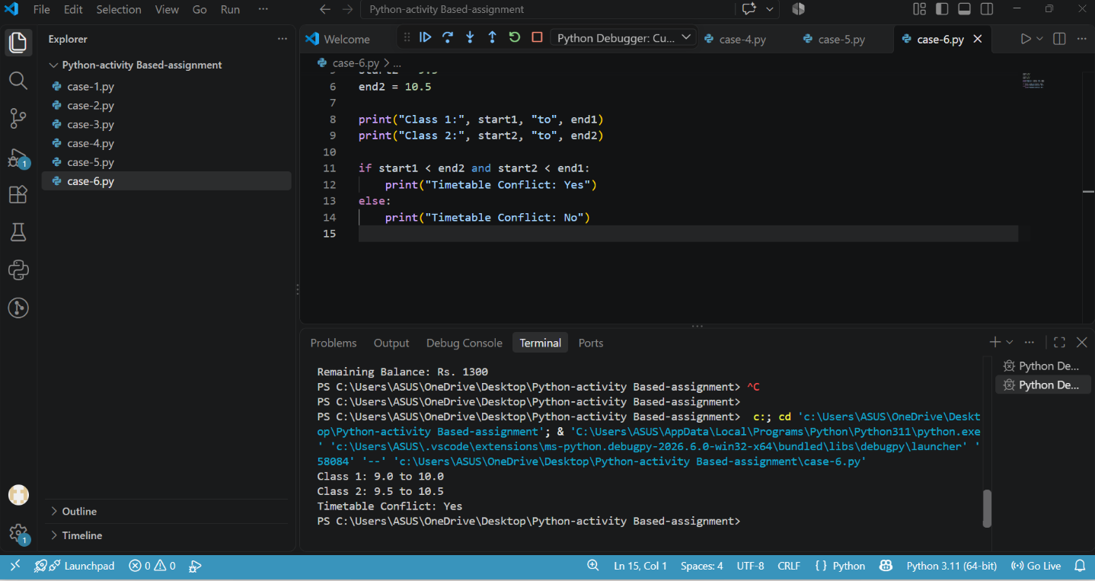

Case Study 7: Nested Loop Examination Seating Generator
1. Problem Statement
In an examination hall, students need to be assigned seat numbers row by row. Develop a Python program using nested loops to display the seating arrangement.
2. Objectives
- Understand nested loops.
- Generate seat numbers row by row.
- Display a simple examination seating arrangement.
3. Assumptions
- The user enters the number of rows and columns.
- Both values must be positive integers.
- Seat numbering starts from 1.
4. Algorithm
- Start the program.
- Read the number of rows and columns.
- Check whether both values are positive.
- Use an outer loop for rows.
- Use an inner loop to display seat numbers in each row.
- Display the seating arrangement.
- Stop the program.
5. Pseudocode
BEGIN
INPUT rows
INPUT columns
IF rows > 0 AND columns > 0 THEN
seat = 1
FOR i = 1 TO rows
FOR j = 1 TO columns
DISPLAY seat
seat = seat + 1
ENDFOR
DISPLAY new line
ENDFOR
ELSE
DISPLAY "Invalid input"
ENDIF
END
6.Flowchart
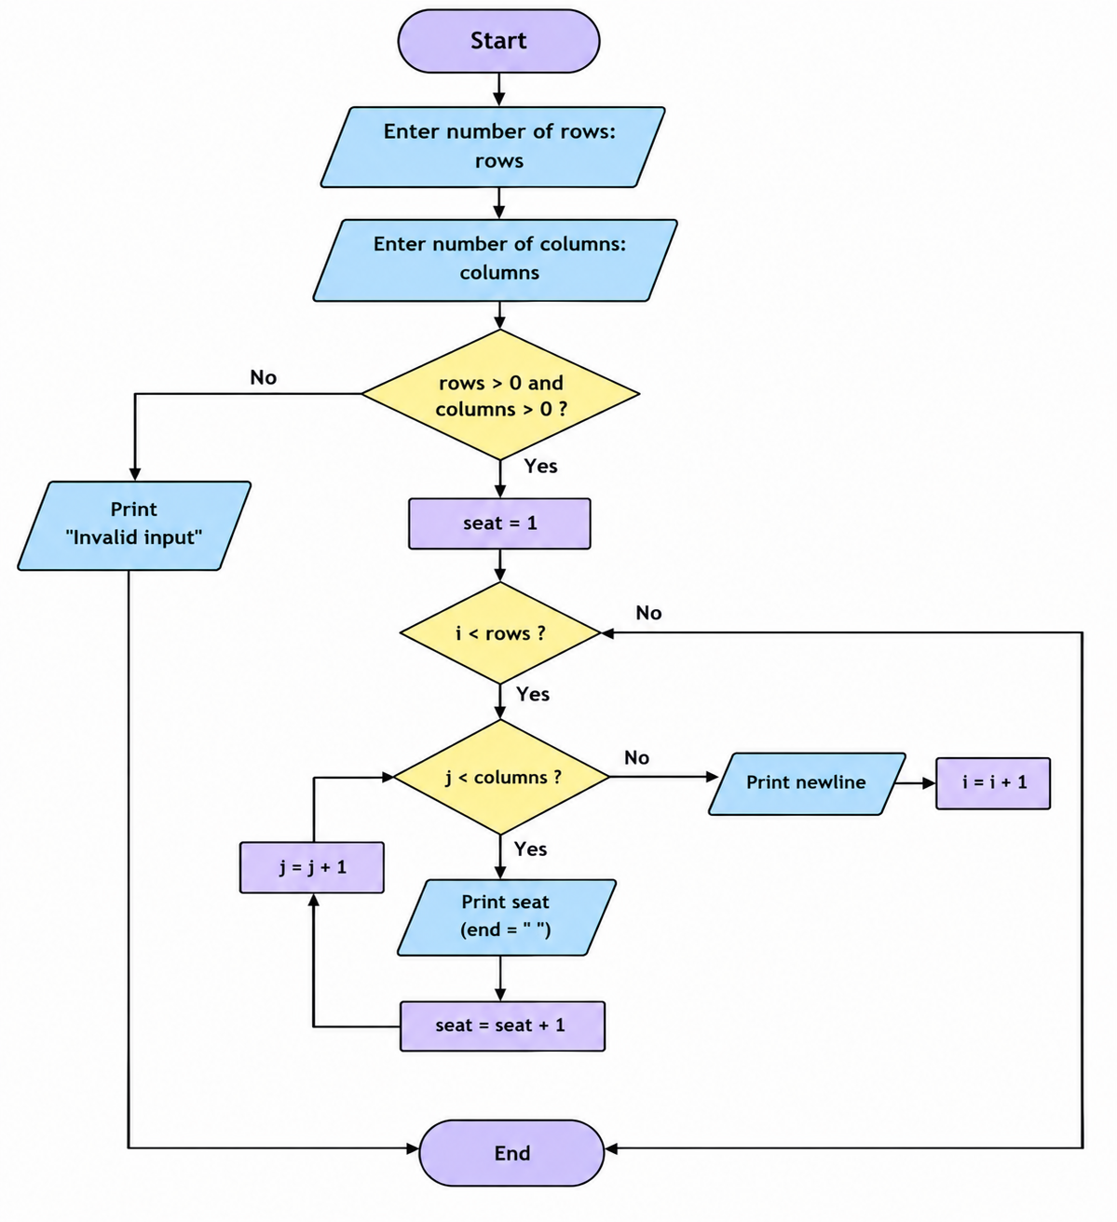

7. Test Cases
Rows | Columns | Expected Result
2 | 3 | 2 rows with 3 seats each
3 | 2 | 3 rows with 2 seats each
1 | 4 | 1 row with 4 seats
0 | 3 | Invalid input
2 | -1 | Invalid input
Conclusion
The program demonstrates how nested loops can generate an examination seating arrangement. It helps students understand how an outer loop controls rows and an
inner loop controls columns.
Output:
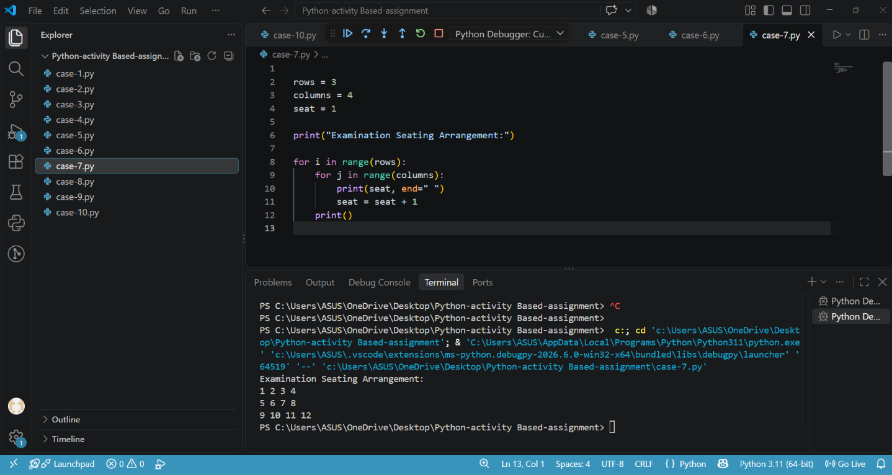

Case Study 8: Library Borrowing and Fine Reconciliation
1. Problem Statement
Develop a Python program to calculate the library fine based on the number of days a book is returned late.
2. Objectives
- Accept the number of late days.
- Calculate the fine according to the rules.
- Display the total fine.
- Validate the input.
3. Assumptions
- Fine is ₹2 per day for the first 5 late days.
- Fine is ₹5 per day for days 6–10.
- Fine is ₹10 per day after 10 days.
- If the book is returned on time, the fine is ₹0.
- Late days cannot be negative.
4. Algorithm
- Start the program.
- Input the number of late days.
- Check whether the number is negative.
- If late days are 0, display ₹0.
- If late days are up to 5, calculate fine at ₹2 per day.
- If late days are up to 10, calculate the first 5 days at ₹2 and remaining days at ₹5.
- Otherwise, calculate the first 5 days at ₹2, the next 5 days at ₹5, and remaining days at ₹10.
- Display the fine.
- Stop.
5. Pseudocode
BEGIN
INPUT late_days

IF late_days < 0 THEN
DISPLAY "Invalid input"
ELSE IF late_days <= 5 THEN
fine = late_days * 2
DISPLAY fine
ELSE IF late_days <= 10 THEN
fine = (5 * 2) + ((late_days - 5) * 5)
DISPLAY fine
ELSE
fine = (5 * 2) + (5 * 5) + ((late_days - 10) * 10)
DISPLAY fine
ENDIF
END
6.Flowchart
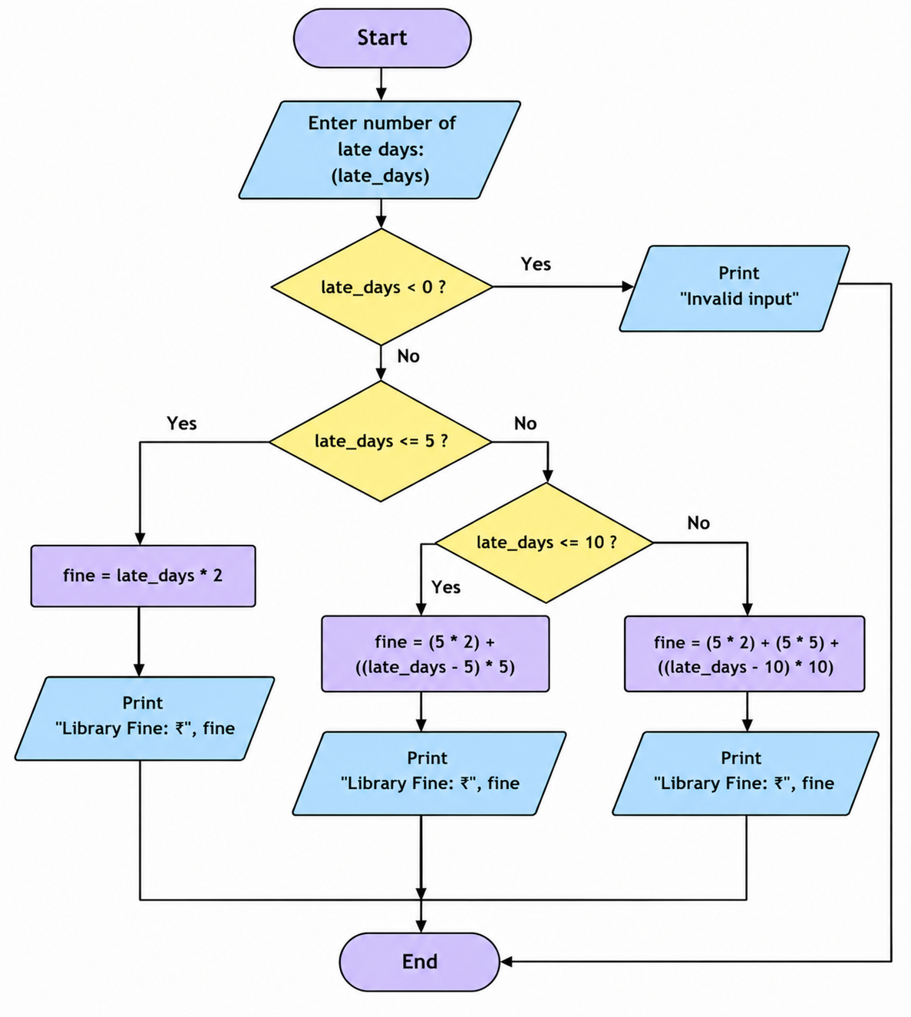
7. Test Cases
Late days | Expected fine
0 | ₹0
3 | ₹6
5 | ₹10
7 | ₹20
10 | ₹35
12 | ₹55
-2 | Invalid input
Conclusion
This program demonstrates conditional statements and arithmetic calculations in Python to determine library fines based on how late a book is returned.
Output:
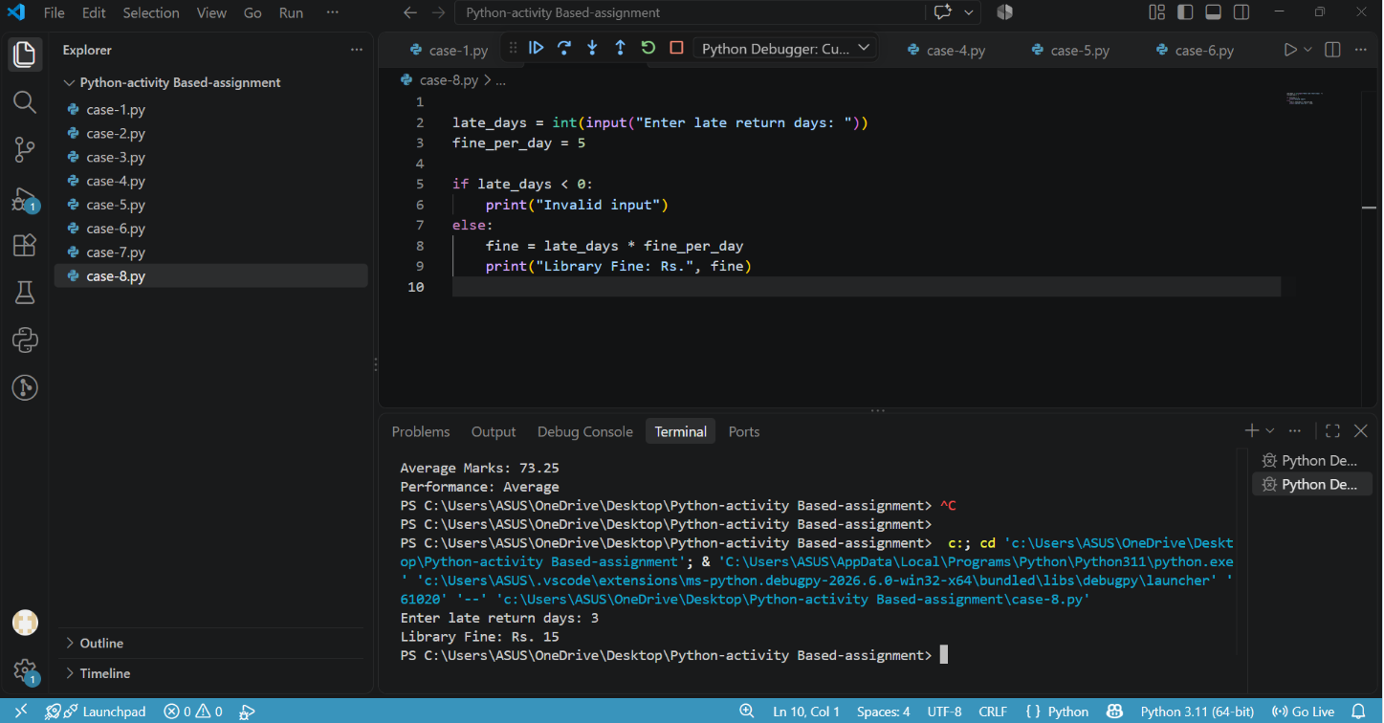

Case Study 9: Student Marks Matrix Analysis
1. Problem Statement
Develop a Python program to store students' marks in a matrix (2D list), calculate each student's total marks, and display the results.
2. Objectives
- Store marks using a two-dimensional list.
- Use nested loops to process marks.
- Calculate each student's total marks.
- Display the marks and totals.
3. Assumptions
- The user enters the number of students and subjects.
- Both values must be positive integers.
- Marks must be between 0 and 100.
- Each student has the same number of subjects.
4. Algorithm
- Start the program.
- Input the number of students and subjects.
- Validate that both values are positive.
- Create an empty list to store marks.
- Use nested loops to input each student's marks.
- Validate every mark.
- Store the marks in the matrix.
- Calculate and display each student's total.
- Stop the program.
5. Pseudocode
BEGIN
INPUT students
INPUT subjects

IF students > 0 AND subjects > 0 THEN
CREATE empty marks_matrix
FOR i = 1 TO students
CREATE empty row
FOR j = 1 TO subjects
INPUT mark
IF mark < 0 OR mark > 100 THEN
DISPLAY "Invalid marks"
STOP
ENDIF
ADD mark TO row
ENDFOR
ADD row TO marks_matrix
ENDFOR
FOR each row IN marks_matrix
total = 0
FOR each mark IN row
total = total + mark
ENDFOR
DISPLAY row, total
ENDFOR
ELSE
DISPLAY "Invalid input"
ENDIF
END

6.Flowchart
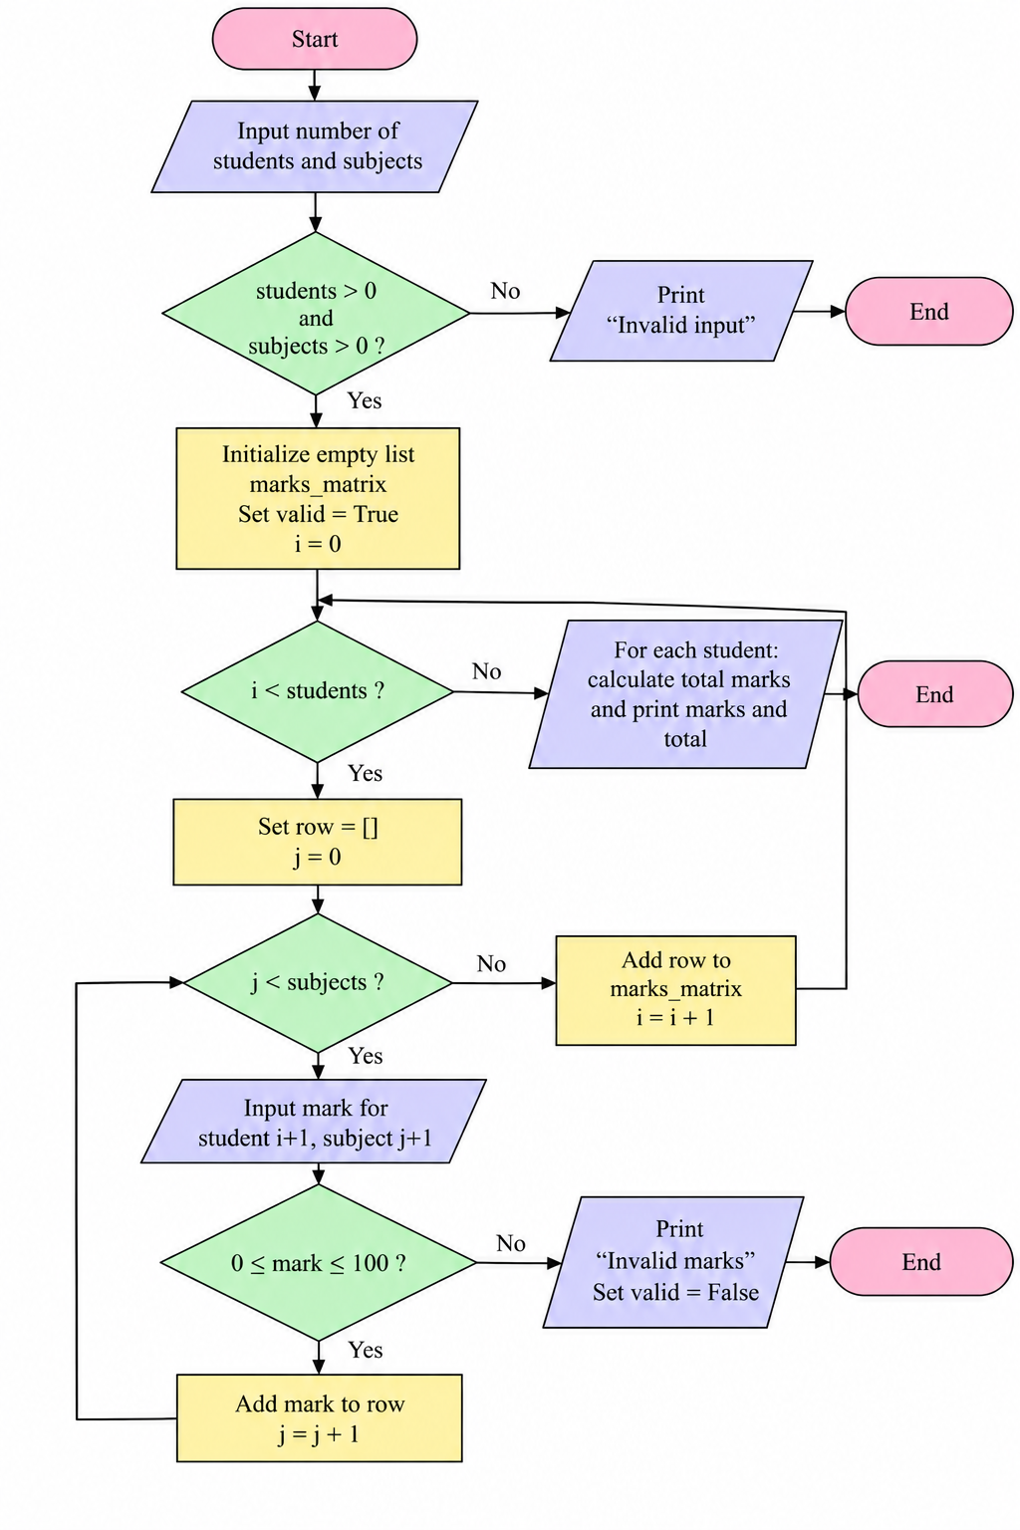

7. Test Cases
Students | Subjects | Marks | Expected result
2 | 3 | 80, 90, 70; 60, 75, 85 | Totals: 240, 220
1 | 2 | 50, 50 | Total: 100
2 | 2 | 100, 90; 80, 70 | Totals: 190, 150
0 | 3 | — | Invalid input
1 | 2 | 110, 50 | Invalid marks
Conclusion
This program demonstrates two-dimensional lists, nested loops, input validation, and total calculation in Python. It can be used as a simple student marks management system.
Output:

Case Study 10: Smart Canteen Order and Stock Management
1. Problem Statement
Develop a Python program for a college canteen that allows students to select food items, enter quantities, calculate the total bill, and check whether the order is valid based on available stock.
2. Objectives
- Display food items and their prices.
- Accept the student's food choice and quantity.
- Check available stock.
- Calculate the total bill.
- Display the order details.
3. Assumptions
- The canteen offers three items: Sandwich, Burger, and Juice.
- Each item has a fixed price and available stock.
- The user selects one item per order.
- Quantity must be positive and cannot exceed available stock.
- Prices and stock values are predefined in the program.
4. Algorithm
- Start the program.
- Define the food items, prices, and stock.
- Display the menu.
- Accept the food choice and quantity.
- Check whether the choice is valid.
- Check whether the quantity is positive and available.
- Calculate the total bill.
- Reduce the available stock.
- Display the order details and remaining stock.
- Stop the program.

5. Pseudocode
BEGIN
SET prices and stock
DISPLAY menu
INPUT choice
INPUT quantity
IF choice is invalid THEN
DISPLAY "Invalid choice"
ELSE IF quantity <= 0 THEN
DISPLAY "Invalid quantity"
ELSE IF quantity > available stock THEN
DISPLAY "Insufficient stock"
ELSE
total = price * quantity
stock = stock - quantity
DISPLAY total bill
DISPLAY remaining stock
ENDIF
END

6.Flowchart

7. Test Cases
Choice | Quantit y | Expected result
1 | 2 | Bill ₹100
2 | 3 | Bill ₹240
3 | 4 | Bill ₹120
5 | 1 | Invalid choice
1 | 0 | Invalid quantity
2 | 10 | Insufficient stock
Conclusion
This program demonstrates dictionaries, conditional statements, arithmetic operations, and stock management in Python. It provides a basic model of a college canteen ordering system.
Output:
